SQL Analysis Report – Task 6 (Elevate Labs)

Prepared by: Rajak
Date: April 30, 2025

Database Setup
CREATE DATABASE Task_6_SQL;
USE Task_6_SQL;

Table: Orders_data
Includes: order_id, order_date, ship_date, customer_name, region, city, category, product_id, sales, quantity, profit

Business Question 1: Monthly Sales Trend
Query:
SELECT
DATE_FORMAT(order_date, '%b') AS Month,
ROUND(SUM(sales), 2) AS Total_Sales
FROM Orders_data
GROUP BY MONTH(order_date)
ORDER BY MONTH(order_date);
Insight: Track monthly sales trends to identify peak seasons.

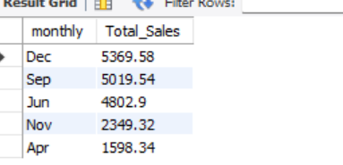

Business Question 2: Monthly Return Rate
Query:
WITH orders_with_returns AS (
SELECT o.order_id, o.order_date,
CASE WHEN r.order_id IS NOT NULL THEN 1 ELSE 0 END AS is_returned
FROM Orders_data o
LEFT JOIN returns_data r ON o.order_id = r.order_id
)
SELECT
DATE_FORMAT(order_date, '%b') AS Month,
COUNT(*) AS Total_Orders,
SUM(is_returned) AS Total_Returns,
ROUND(SUM(is_returned)/COUNT(*)*100, 2) AS Return_Rate_Percentage
FROM orders_with_returns
GROUP BY MONTH(order_date)
ORDER BY MONTH(order_date);

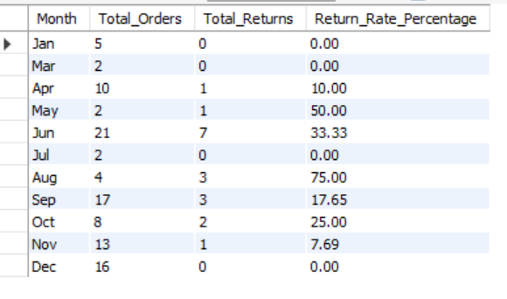

Insight: Identify months with high return rates.

Business Question 3: Sales by City
Query:
SELECT city,
ROUND(SUM(sales), 2) AS Total_Sales
FROM Orders_data
GROUP BY city
ORDER BY Total_Sales DESC;
Insight: Recognize top-performing cities by total sales.

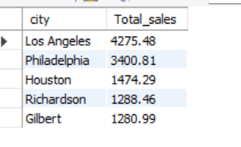

Business Question 4: Total Orders & Returns
Query:
SELECT
COUNT(DISTINCT order_id) AS Total_Orders,
(SELECT COUNT(*) FROM returns_data) AS Total_Returns
FROM Orders_data;
Insight: Understand overall return volume.

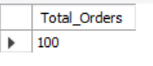

Business Question 5: Profit by Region
Query:
SELECT region, ROUND(SUM(profit), 2) AS Total_Profit
FROM Orders_data
GROUP BY region
ORDER BY Total_Profit DESC;
Insight: Identify regions contributing the most profit.

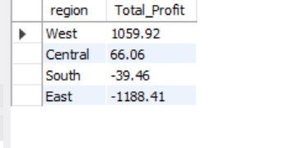

Business Question 6: Average Shipping Time
Query:
SELECT
CONCAT(ROUND(AVG(DATEDIFF(ship_date, order_date)), 2), ' Days') AS Avg_Shipping_Time_Days
FROM Orders_data;
Insight: Measure efficiency of order fulfillment.

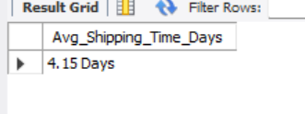

Business Question 7: Top Categories by Quantity Sold
Query:
SELECT category, SUM(quantity) AS Total_Quantity
FROM Orders_data
GROUP BY category
ORDER BY Total_Quantity DESC;
Insight: Track which categories sell the most units.

Business Question 8: Highest Sales by Product
Query:
SELECT product_id, SUM(sales) AS Total_Sales
FROM Orders_data
GROUP BY product_id
ORDER BY Total_Sales DESC
LIMIT 5;
Insight: Identify best-selling products.

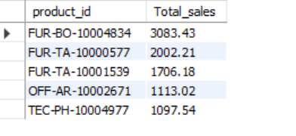

Business Question 9: Monthly Profit Trend
Query:
SELECT DATE_FORMAT(order_date, '%b') AS Month, SUM(profit) AS Total_Profit
FROM Orders_data
GROUP BY MONTH(order_date)
ORDER BY MONTH(order_date);
Insight: Helps monitor profitability over time.
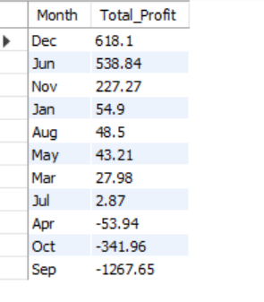

Business Question 10: Category-wise Return Rate
Query:
WITH order_returns AS (
SELECT o.order_id, o.category,
CASE WHEN r.order_id IS NOT NULL THEN 1 ELSE 0 END AS is_returned
FROM Orders_data o
LEFT JOIN returns_data r ON o.order_id = r.order_id
)
SELECT category,
COUNT(*) AS Total_Orders,
SUM(is_returned) AS Total_Returns,
ROUND(SUM(is_returned)/COUNT(*)*100, 2) AS Return_Rate_Percentage
FROM order_returns
GROUP BY category;
Insight: Identify which product categories face higher returns.

This document serves as a complete SQL reporting summary answering business-critical questions using real sales and returns data.

